

Tutorial and User Guide

Introduction
Welcome to K2 (web), an assistive web app.

This document is written for you, Kay, as well as for the AI agent inside the K2 app, which upon reading this document, will be able to answer questions you may have about using the app. So there is no need for you (Kay) to read any of this if you don’t want to. I (Phil) will gladly try to answer any questions, and if I am unavailable, the AI agent inside K2 should be able to help you use the app whenever you need it. But if you like, reading some of this document may give you a basic idea of what K2 might be able to do for you.

Also, there is no expectation that you will use the K2 app at all. You have a lot going on. You don’t need anything that will complicate your life. At this moment, your life should be as stress-free as possible. There are already many well-tested assistive technologies, vetted by and well-known to your health care team, that will give you support if you need it. However, today’s technologies are changing fast, particularly in AI. That is where maybe the K2 app may be breaking some ground compared to other assistive apps. If you are able to give feedback on it, and we make the app open source, down the road it might prove useful not only to you but to others, or it might be influential to assistive products that follow. AI is going to fundamentally change human society, in some cases for better and in some cases for worse. K2 is one effort to find a case where AI changes lives for the better.

Now, what might K2 be able to do for you? K2 is designed to assist you both as a communication device and as a personal assistant.

As a communication device, at its most basic, K2 is similar to the Speech Assistant AAC app that you have already been using. Specifically, K2 can speak phrases in your Elevenlabs voice. The spoken phrases can be generated from text phrases that you enter on the spot into a text editor, or from text phrases in a list of phrases that you have created and saved for later use over and over. If you like your Speech Assistant AAC app, it is possible to replace or augment the saved phrases in K2 with the same phrases that you have in your Speech Assistant AAC app. In addition, as a communication device, K2 can send those phrases as text to other apps, including your text messaging app, your email app, and your Internet browser. Thus other people should be able to hear you and read your written communications as they ordinarily do.

That, however, is just the easy half of the communication problem, namely the output half.

K2 aspires to help with the more difficult half of the communication problem, namely the input half. You can think of any communication as going through a communication channel from point A (the input) to point B (the output):

Communication channel
Point A
Point B
At times it may be hard for you to input text into the communication channel as fast as you might like. There is an input bottleneck. K2 tries to help overcome the bottleneck by knowing you well (your interests, your relationships, your schedule, etc.), by knowing the context of your ongoing conversation, and by knowing what’s going on in your immediate environment. With such information, K2 tries to read your mind, or at least predict what you might be wanting to say. Then, on an ad hoc basis, K2 pre-fills a few buttons with words, phrases, and actions that you might want to take at the moment. Though this prediction part is still weak, the aim is to improve it continuously. The main technology we rely on here is the Large Language Models (LLMs) that are behind the recent advances in AI. LLMs are trained precisely to predict text from past text and a context.

That brings us to the use of K2 as a personal assistant. The assistant is an AI agent built into K2. Not only does the agent try to predict what you want to say, but it also tries to predict what you want to do, and what you want to know. You can ask it anything, like a normal AI that you can find online. But it is also connected to your home automation system (or it could be), so that you could conceivably ask it to lower the lights, play some music, check who’s at the front door, or raise the bed. And it should also know about the K2 system itself. In some cases, you can just ask it to do something (like “send a text message to Emma that we’re running late”, or “make the text larger”, or “tell me how to type emojis in K2”). It will tell you if it cannot do something yet.

K2 is currently delivered as a web app. To get it, you can just enter https://k2-web-production.up.railway.app/ into any browser. You can therefore use it on your phone, on your iPad, on your laptop, or for example, on a dedicated PC-based device with Tobii eye tracker attached to your wheelchair. If you want a change, I can make the change in the app and release it right away. If you refresh the page, it should immediately load the updated app. Actually, anyone can use the app. However, at the moment it does not have a login system, since you are presumed the sole user. Thus the K2 app is tied to your Elevenlabs voice and my Gemini assistant. These services are paid for by small subscription fees – trivial in the scheme of things. Nevertheless, we don’t want random people using the app. Still, with that understanding, you can feel free to share the URL with interested family or healthcare providers. Each browser instance will get its own fresh copy, so users on different machines will not see each other’s conversations with K2. In fact, even your phone and your iPad will treat you as different people. Later in the document, we’ll discuss how to sync them if you’d like.

The K2 app is designed to adapt to you. It assumes that you can read, direct your eye gaze, and click something. But some days you may be feeling good enough to use faster methods of input, or “shortcuts”. If you can speak (even whisper) to K2, then you can do that. If you can type on a physical or virtual keyboard, then you can do that. If you can move a mouse and point and click, you can do that. For example, if you are looking at the chat log and you want to scroll up, you can use arrow keys, or drag a mouse on the scrollbar, or just look at the top of the log, and it will scroll up. If you want to enter text, you can speak, or type with your fingers, or look at buttons on the keyboard (or elsewhere) and click to select. Buttons will light up when it detects your gaze, so you will have positive feedback when to click. So you should have many ways to do the same thing, depending on how you are feeling that day, and where and when you want to spend the effort. Even things like eye gaze accuracy can be adjusted in the K2 Settings panel.

Note, however, that I have not yet tested K2 with hardware eye gaze tracking. So far eye gaze tracking has been simulated with a mouse. This should change soon when I get a Tobii PCEye 5.

There are a couple of deliberate exceptions on the usability rule that everything should be controllable with eye gaze and clicking. One exception occurs in the small mobile form factor. K2 assumes that if you are using a mobile phone, then you don’t need eye gaze tracking, and you have the capability of using your fingers to touch the screen, including not just clicking, but also dragging. These assumptions make it possible to access K2’s functionality on a mobile phone. Using K2 on a mobile phone can be useful to you, for example when you are out and about and you need help speaking (like when you use your Speech Assistant AAC app). You can then return home and use other features of the app on your iPad, and if you sync, it will remember your interactions from your phone. Another usability exception is the Settings panel. At the moment the Settings panel is not very user-friendly, as it has mostly been used for debugging and features that do not change frequently. This can be improved over time.

In conclusion, K2 takes advantage of technologies that were not available or not mature just five years ago: eye gaze, text-to-speech, home automation, and AI. K2’s goal is to combine these technologies in a natural and synergistic way, not only to help overcome the communication bottleneck, but also to provide some of the kinds of assistance that a personal assistant may provide.

Overview
Open up K2 for the first time on your iPad, by opening your Safari browser and typing https://k2-web-production.up.railway.app/, or by clicking on this link when on your iPad. You should see something like this:
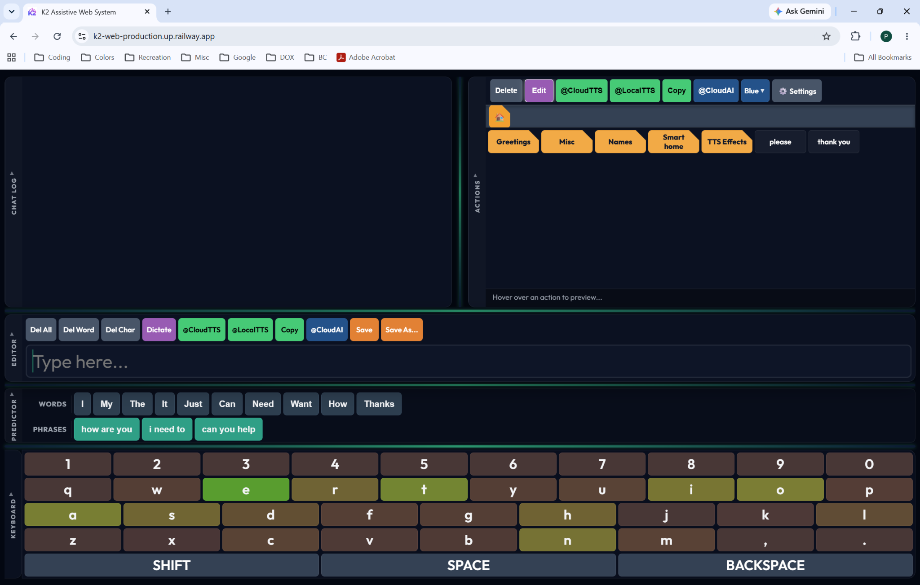

If you open it on your phone, you should see something like this:
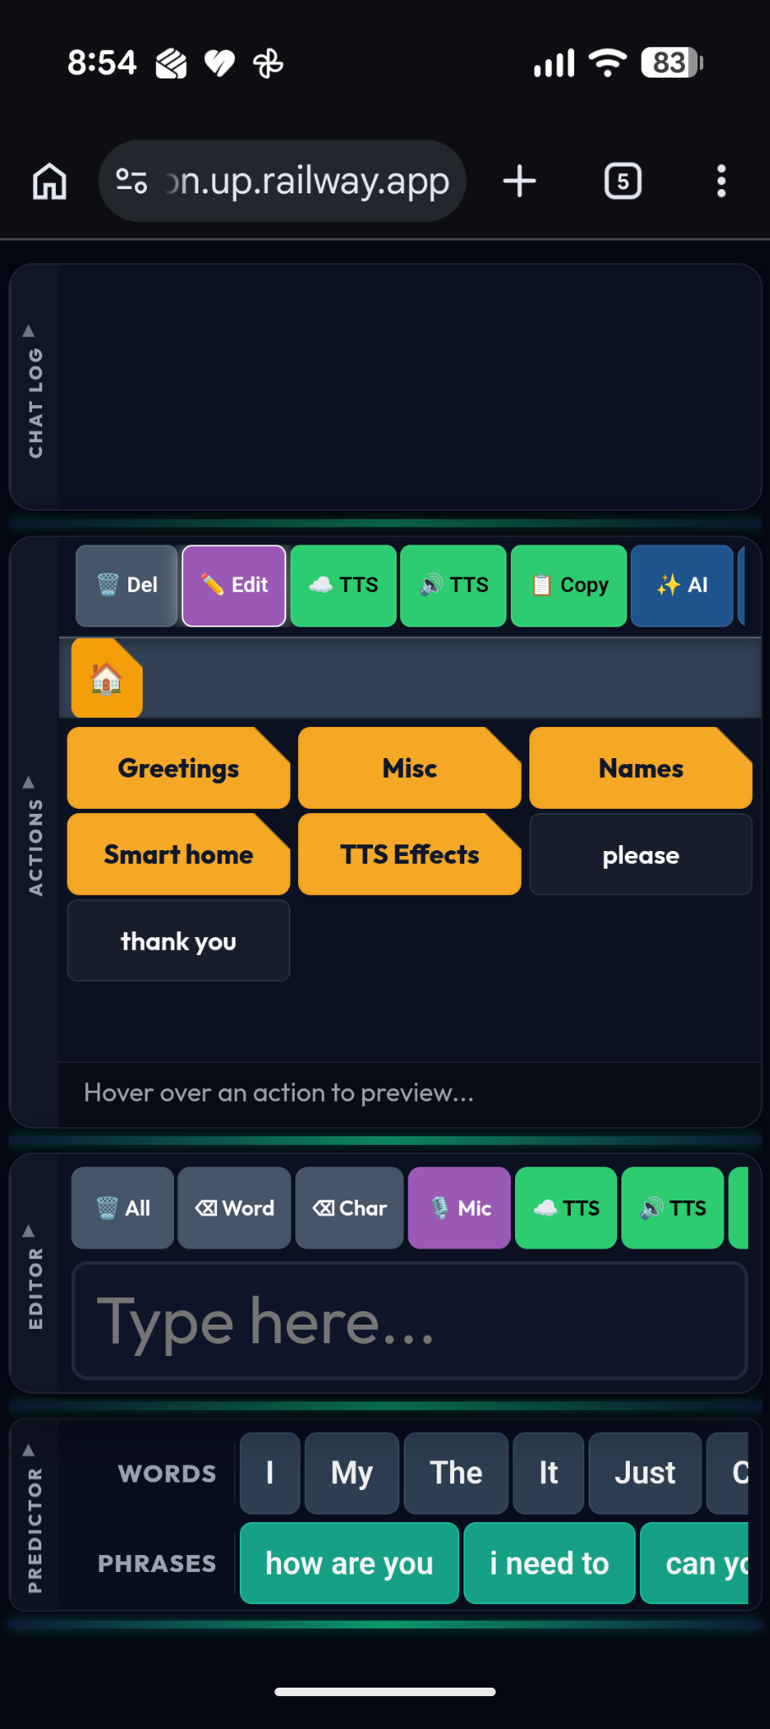

There are five panels: the Chat Log, the Actions panel, the Editor, the Predictor, and the Keyboard. These are briefly described here, and described in more detail in the next sections.

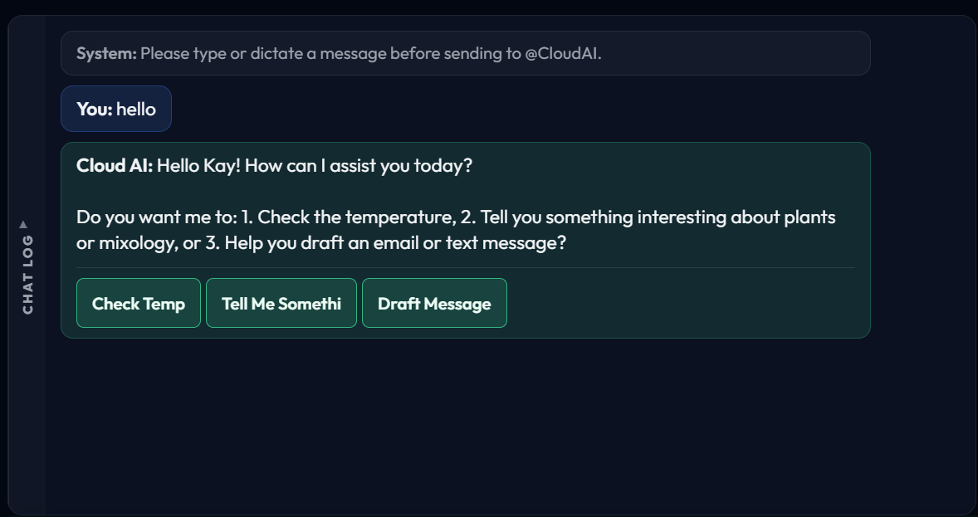
The Chat Log (pictured above) is something like the text messaging app on your phone, if you were exchanging text messages with someone. It records the conversation between you and your agent, CloudAI. CloudAI is the name of your AI agent in K2. CloudAI will usually respond to your text messages not only with a text message, but with a few clickable options, represented as buttons. You can click directly on these buttons to do something, if you want. The Chat Log also includes messages from the K2 system itself, to let you and CloudAI know when it is doing something.

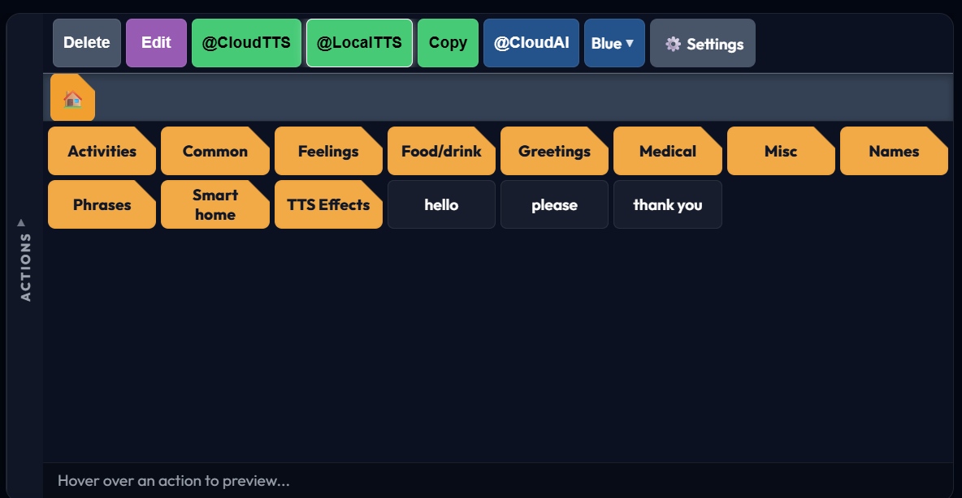
The Actions panel (pictured above, after importing categories from Speech Assistant AAC) is the place for your pre-stored actions, which are recorded as text phrases. You can access your pre-stored actions by clicking on them, such as by clicking on the action button “hello”. You can get to more actions by navigating to them down a hierarchy of categories, such as by clicking on the category button “Activities”. That will lead you to more actions buttons and/or more category buttons. This is similar to a hierarchy of folders on your phone or computer. A top toolbar of action mode buttons sets the mode of what happens when an action button is clicked. For example, if the mode is set to Edit, or CloudTTS, or CloudAI, a clicked action can be respectively sent to the Editor for subsequent editing, sent directly to the Elevenlabs text-to-speech (TTS) synthesizer, or sent directly to CloudAI.

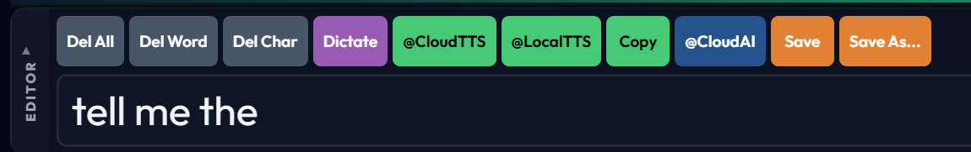
The Editor panel (pictured above) is where text can be composed in the editor text box. Text can be entered into the editor text box by typing text on a physical or virtual keyboard, speaking or whispering words (which are recognized by AI and turned into text), clicking on an action button (which retrieves its stored text phrase), clicking on words or phrase buttons in the Prediction panel (which are predictions of what you might want to type next), or clicking on buttons in the Chat Log, which are actions suggested to you by CloudAI. Once text is entered into the editor text box, it can be edited by deleting any portion of the text at any location, entering further text at any location, and so on. Once the text is edited, a top toolbar of editor buttons allows you to do something with the edited text. For example, if you click on @CloudTTS, @CloudAI, or Save, the text that you have composed in the editor text box can be respectively sent directly to the Elevenlabs text-to-speech synthesizer, send directly to CloudAI as an instruction or reply to your agent, or saved as an action for future use.

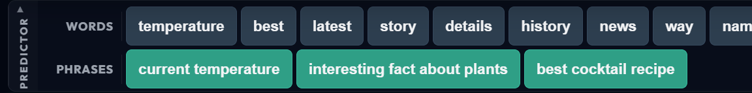
The Predictor panel displays a list of words and a list of phrases that it thinks may be appropriate for completing the sentence that you are already composing in the editor text box. The idea is to accelerate the input process where possible, using a Large Language Model that takes into account not only the immediately preceding words, but also takes into account the context of your entire chat log history, what it knows about you and your contacts, what it knows about your current environment, and what it knows about K2 itself. [At the moment the Predictor seems to be a bit buggy, and may predict things that don’t make much sense, but this will be fixed.]

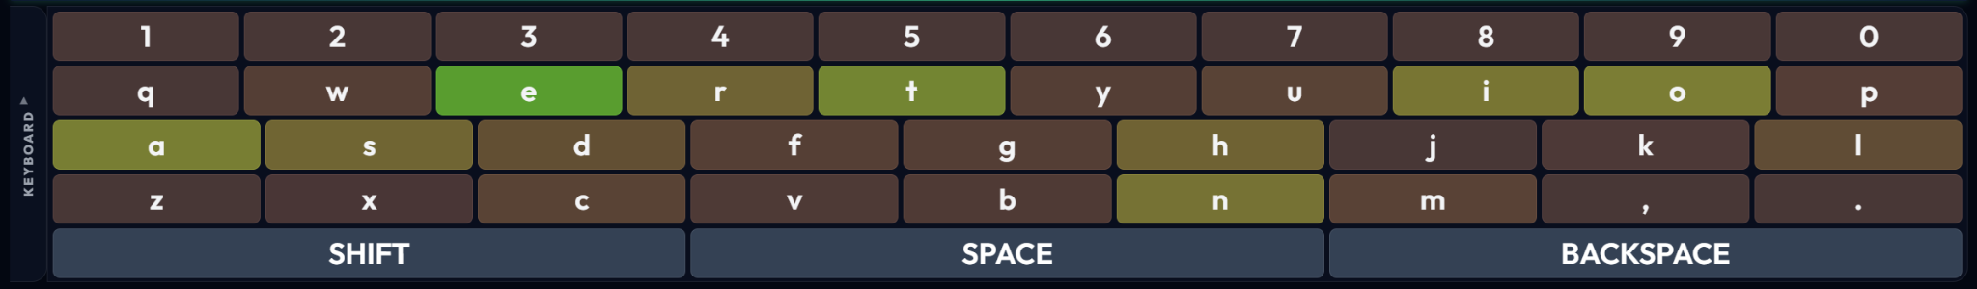
Finally, the Keyboard panel displays a virtual keyboard similar to what you might find on your phone or iPad. In fact, there are options in K2’s Settings that let you use the built-in operating system (OS) virtual keyboard, instead. However, although K2’s custom keyboard has not yet been fully developed and has only rudimentary functionality at present, later it may be specialized to fast eye gaze input with, for example, larger capture wells for likely next letters (shown simply highlighted above), eye swiping, or other alternatives.

Each of the five panels has a vertical label on its left side: CHAT LOG, ACTIONS, EDITOR, PREDICTOR, and KEYBOARD, respectively. Clicking on a panel’s label closes (i.e., minimizes) the panel and replaces it with a horizontal label. Clicking again on the horizontal label opens the panel again. This might be useful to get a panel out of the way to give more real estate to panels that you are actually working with.

To be clear about what it means to “click” on a button: If you see the button on a touch screen like your iPad, you can just touch the button. If you have a mouse, you can position the mouse over the button (at which point the button will highlight to acknowledge that the mouse is over it) and then you can click the mouse button. If you have an eye gaze tracker, you can gaze at the button (at which point the button will highlight to acknowledge that it is the target of your gaze) and then you can click the mouse button. All of these will “click” the button. This applies to clicking on any button in the Keyboard or in any of the other panels. There are settings in K2’s Settings that set the minimum target (i.e., button) width and height. These can be adjusted depending on your capabilities.

K2 is designed so that you could use it in many different ways, even inter-mixed. The next section will provide some illustrative examples.

Example Usage

Immediate text-to-speech
Sometimes you just want to say something quickly, like “Pete”, to draw Pete’s attention, say. To do so, in the action panel, in the toolbar click on the @CloudTTS mode, and then in the list of actions click on an action labeled “Pete”. This sends the word “Pete” immediately to the Elevenlabs text-to-speech synthesizer, and you hear “Pete”.

To follow up, you could then navigate to and click on another action, such as “I would like”. Since the action panel is already in @CloudTTS mode, the phrase “I would like” would be sent immediately to the Elevenlabs text-to-speech synthesizer, and you would hear “I would like”.

Finally, you could navigate to and click on another action, such as “water”. As before, you would hear “water”.

If you don’t want gaps to appear between “Pete”, “I would like”, and “water”, you could of course store an action button that says, “Pete, I would like water”. Then you could click it to hear “Pete, I would like water” all in one shot. For common phrases, this might be useful. You can create a mix of long common phrases and shorter snippets, as appropriate.

Edited text-to-speech
A more common usage pattern might be to compose your sentences before you send them. To do that, in the action panel, in the toolbar, click on the Edit mode, and then click on the same sequence of actions as before: “Pete”, “I would like”, and “water”. As you click on the actions, they appear sequentially in the editor text box, first as “Pete ”, then “Pete I would like ”, and finally “Pete I would like water ”. Lastly if you click on the “@CloudTTS” button in the Editor, you will send the contents of the editor text box to the Elevenlabs text-to-speech synthesizer, and you will hear “Pete I would like water” without any gaps appearing between the constituent phrases. An advantage to this way of communicating is that your message goes out as a coherent sentence, rather than in possibly confusing parts. You can use the editor to assemble what you want to say before you say it.

Another advantage to using the editor text box as an intermediary is that you can confirm the message before it is sent out. This is important because sometimes it may not be clear from the label on an action button what message is stored beneath it.

Still another advantage to using the editor text box as an intermediary is that you can edit it there. For example, you can insert the word “hot”, as in “Pete I would like hot water”. Even if you have stored a complete sentence such as “Pete, I would like water”, you can always load it into the editor and then edit it, perhaps by inserting “hot” or “cold”, replacing “like” by “love”, deleting “would”, and so forth.

A related advantage to using the editor text box as an intermediary is that it allows you to save templates that you can later customize. Using templates can be a very useful way of creating messages.

For these reasons, Edit mode is the default mode in the action panel. For most of what you may want to do, actions will pass through the editor text box, and you will distribute them from there.

Composed text-to-speech
Of course you can always start from scratch by typing into the editor text box. You don’t need to load any pre-saved action into the editor text box. If the text box is not already empty, you can delete all text by clicking “Del All”. Then begin typing.

Dictation
Although it is increasingly hard for you to speak, perhaps especially if it involves vocalizing, there might be occasions where it is easier to dictate a word or more, than to type it. To do that, place the cursor in the text editor where you want to insert the dictation. (You can place the cursor by clicking at the desired location in the text box, by pointing with the mouse and clicking, or by gazing and clicking.) Then click the Dictate button and begin speaking, or whispering. When you are done, click the button again to signal the end of your dictation. Your words will appear inserted into the text at the desired location.

Action categories (flat vs deep hierarchy)

Conversing with your agent, CloudAI

Composing text messages

Composing email

Controlling home automation

Using CloudAI for K2 help

Detailed Descriptions of Panels

Chat Log

Action Panel

Editor

Predictor

Keyboard

FAQ
How do I create a new action?
How do I edit an existing action?
How do I delete an action?
How do I create a new category of actions?
How do I delete a category of actions?
How do I change the color of a button for an action or action category?
How can I speak or whisper to enter text into the text editor?
How does K2 know about me?
How do I get K2 to know more about me?
What does K2 know about me?
How can I import my contacts?
How do I backup the actions and everything else in K2?
How do I restore the actions and everything else in K2?
I’ve started using a different browser or device. How do I get K2 to look the same as before?
How do

Not very inventive, right? Maybe that’s something to change. The desktop version of the app also has LocalAI, in case the machine is offline. But in the web app, since you’re visiting a web page, you’re already online, so LocalAI is not needed, leaving only CloudAI in the K2 web app.

